My validation rules

No duplicate state names in the same machine.
No duplicate transition names in the same machine.
The start state must be declared in the state list.

Transitions should only be between states in the same machine. States in different machines should not connect with each other.
A warning when a state connects to itself.

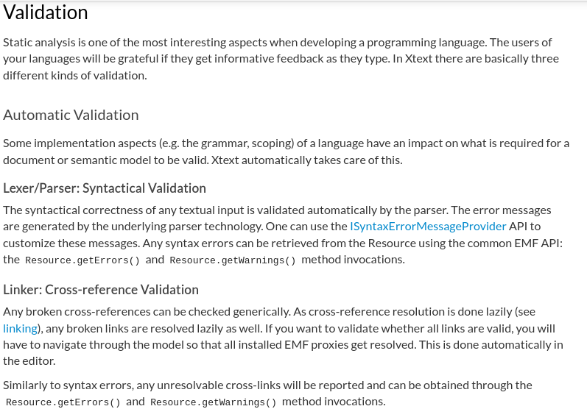
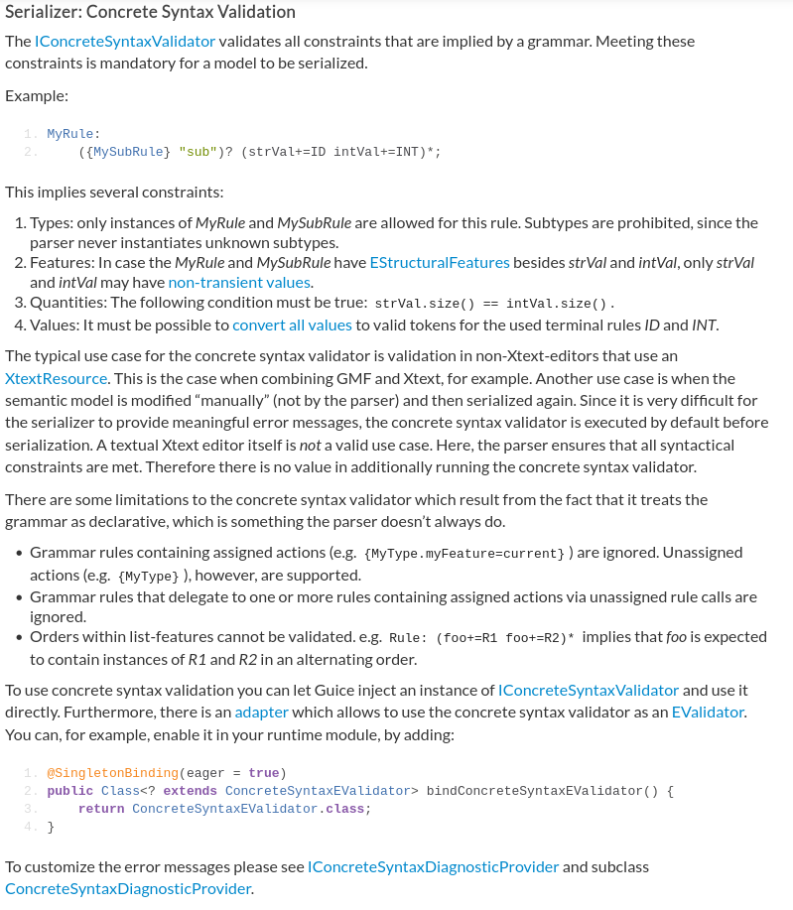
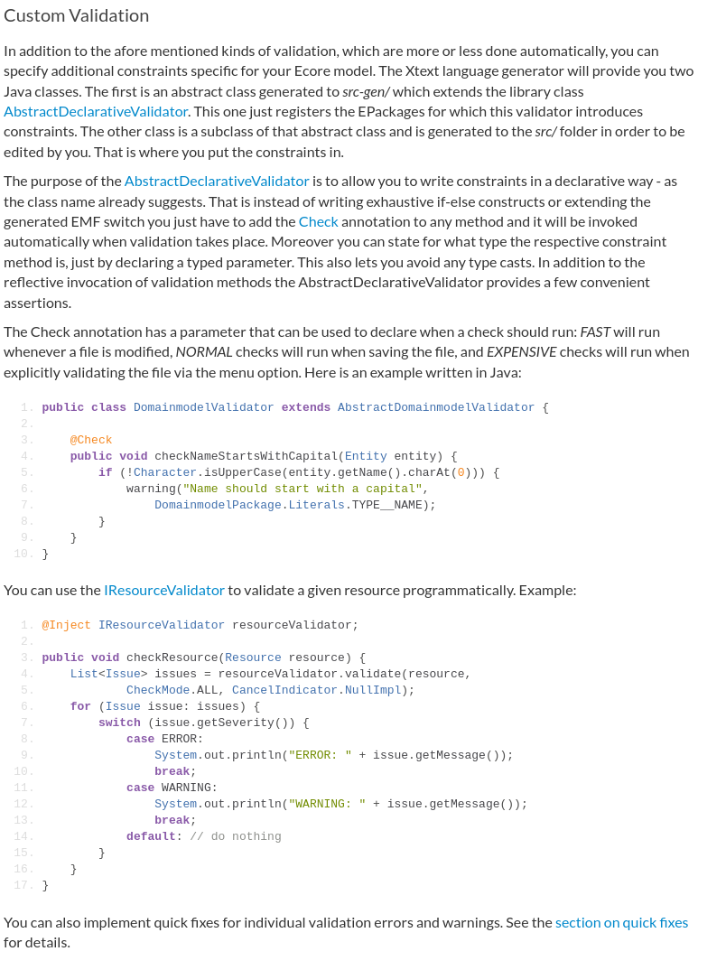

Validation
ISyntaxErrorMessageProvider API is used to customize error messages

